Marketing Campaign ROI Analysis

By Himanshu Singh

Business Objective

The primary objective of this analysis is to evaluate the performance of GlowUp’s marketing campaigns across various channels, including social media, influencer collaborations, email marketing, and offline events. The goal is to identify which campaigns generated the highest returns in terms of revenue and customer conversions.
This analysis aims to:
- Measure the effectiveness of each campaign by analyzing key performance indicators such as revenue generated, conversions, and return on investment (ROI)
- Compare the performance of different marketing channels to determine which channels deliver the most cost-efficient results
- Identify high-performing and underperforming campaigns based on ROI and cost per acquisition (CPA)
- Provide data-driven recommendations to optimize future marketing strategies and improve overall campaign efficiency

Dataset Overview
The dataset contains marketing campaign data from GlowUp, a beauty and skincare startup, covering both online (social media, influencer, email) and offline (events) campaigns.
Each row in the dataset represents a single campaign and includes 11 key variables related to campaign performance, cost, and engagement.
The dataset captures:
- Campaign Information: CampaignID, CampaignName, Channel
- Time Duration: StartDate, EndDate
- Cost & Revenue Metrics: Spend, RevenueGenerated
- Performance Metrics: LeadsGenerated, Conversions
- Engagement Metrics: Clicks, Impressions
To evaluate campaign effectiveness, key metrics were derived:
- ROI (%): Measures campaign profitability
- CPA: Cost per acquisition
- Conversion Rate (%): Efficiency of converting leads into customers
- CTR (%): Engagement level of campaigns
Basic data quality checks were performed to ensure accuracy, including removal of duplicates, validation of missing values, and consistency in date and numeric formats.
Overall, this dataset provides a comprehensive view of marketing performance by combining cost, engagement, and revenue metrics, enabling data-driven decision-making for optimizing campaign effectiveness and future budget allocation.

Exploratory Data Analysis (EDA)

Exploratory Data Analysis (EDA) was conducted to analyze the performance of marketing campaigns across different channels. The objective was to identify patterns, compare performance metrics, and evaluate campaign effectiveness using key KPIs such as ROI, CPA, conversions, and engagement metrics.

Campaign Spend: Total money spent = 100894065.8

Leads Generated: Total = 2531213

Conversions: Total = 1271369

Revenue Generated: Total sales attributable = 219746242.6

ROI (%): For Total =((219,746,242.6−100,894,065.8​)/100,894,065.8​*100) = 117.8%

Cost per Acquisition (CPA): Spend ÷ Conversions = 100,894,065.8​/1,271,369 = 79.36

Engagement Metrics:
- Clicks: 10,360,935
- Impressions: 125,343,105
- Click-Through Rate (CTR %): 8.27%

1. Campaigns delivered the highest ROI:

Highest ROI Channels

Content Marketing → Highest average ROI

Search Engine Ads → Very strong performance

TV Commercials → High profitability

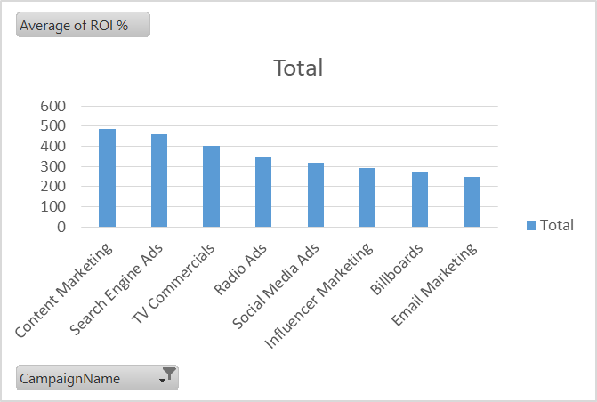
The analysis of average ROI across channels shows that:
- Content Marketing delivered the highest ROI, followed by Search Engine Ads and TV Commercials, indicating strong profitability
- Channels such as Social Media Ads and Radio Ads showed moderate performance
- Email Marketing and Billboards had relatively lower ROI compared to other channels

2. Conversions and cost per acquisition:-

Content Marketing : Most cost-efficient channel High conversions (176K) Lowest CPA (268)
Search Engine Ads : Highest conversions (198K) but Costly CPA is relatively high (372)

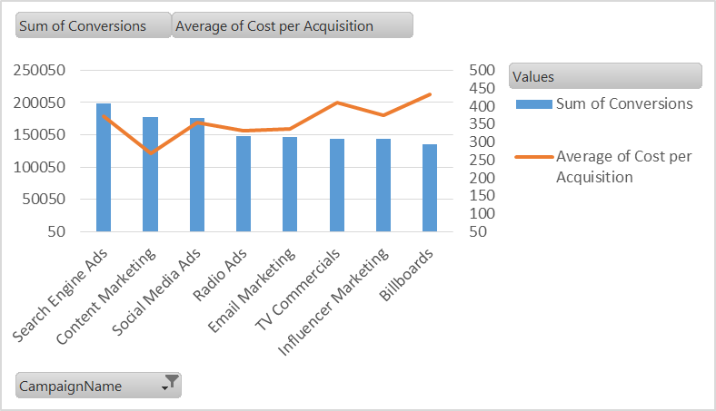

The effectiveness of marketing channels was evaluated using total conversions and cost per acquisition (CPA).
- Content Marketing emerged as the most cost-efficient channel, delivering high conversions with the lowest CPA
- Search Engine Ads generated the highest number of conversions but at a relatively higher CPA, indicating strong performance with scope for cost optimization
- Social Media Ads, Radio Ads, and Email Marketing showed moderate performance with balanced conversions and acquisition costs
- Billboards and TV Commercials were the least efficient channels due to higher CPA, making them more expensive for customer acquisition
Overall, digital channels demonstrated better efficiency compared to traditional channels.

3. Campaigns that generated high leads but low conversions.Why?
I used Pivot Table analysis to identify that Influencer Marketing generates high leads but has comparatively lower conversion efficiency, indicating optimization opportunities in the conversion funnel.

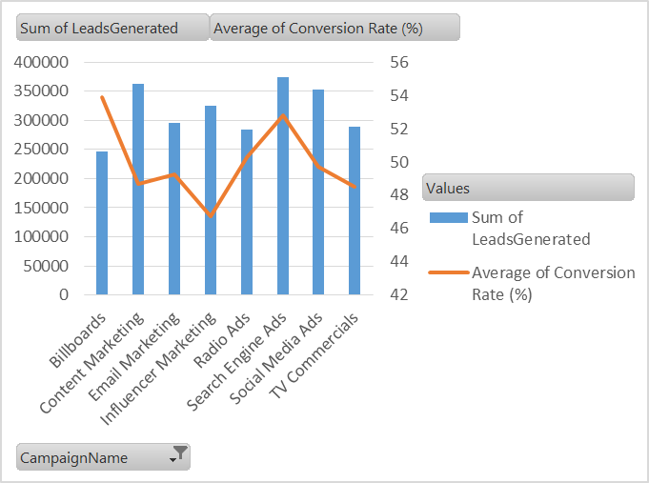

Problem Channel Identified: Influencer Marketing
Leads Generated: 325K (High)
Conversion Rate: 46.7% (Lowest among all channels)
This indicates that the channel is effective in attracting potential customers but less efficient in converting them into actual buyers

Slight Concern: Content Marketing
Generates a high number of leads
Conversion rate is slightly lower compared to top-performing channels
Indicates potential scope for improvement in conversion efficiency

The analysis indicates that most channels maintain a relatively strong conversion rate, suggesting an overall efficient marketing funnel. However, Influencer Marketing stands out as a channel with high lead generation (325K) but the lowest conversion rate (46.7%) among all channels.
This suggests that while influencer campaigns are effective in attracting potential customers, they are less efficient in converting those leads into actual customers.
Content Marketing also shows high lead generation but a slightly lower conversion rate compared to top-performing channels, indicating some scope for improvement.

Insights

Digital channels, especially Search Engine Ads and Content Marketing, consistently outperform traditional channels in terms of ROI, conversions, and cost efficiency. Campaign performance shows a strong link between higher conversion rates and better ROI.

1. Next quarter’s marketing budget be allocated based on past performance:-

Based on past campaign performance, the marketing budget should be allocated towards channels that deliver high ROI, strong conversions, and cost-efficient customer acquisition.
- Increase budget allocation for Search Engine Ads, as they generate the highest ROI and strong conversion volume, making them the most effective channel
- Scale Content Marketing, as it provides high conversions at the lowest CPA, indicating strong cost efficiency
- Maintain or moderately increase investment in Social Media Ads, as they show balanced performance in terms of conversions and engagement
- Optimize Influencer Marketing, as it generates high leads but lower conversion efficiency; budget should be used selectively with improved targeting strategies
- Reduce budget allocation for traditional channels such as Billboards and TV Commercials, as they have higher CPA and comparatively lower efficiency
- Re-evaluate Email Marketing performance, as it shows moderate results and may require optimization before scaling

Recommendations

strategies to improve ROI across campaigns
Based on the analysis of campaign performance, the following strategies are recommended to improve ROI:
- Focus on high-performing channels
Increase investment in Search Engine Ads and Content Marketing, as they deliver strong ROI, high conversions, and better cost efficiency
- Optimize underperforming channels
Improve Influencer Marketing by refining audience targeting and selecting more relevant influencers to enhance conversion rates
- Improve audience targeting
Use data-driven segmentation to target high-intent users, which can increase conversion rates and reduce wasted spend
- Enhance landing pages and user experience
Optimize landing pages, messaging, and offers to improve the conversion funnel and turn more leads into customers
- A/B testing and campaign optimization
Continuously test creatives, ad copies, and campaign formats to identify what works best and improve performance
- Optimize budget allocation
Shift budget from high CPA channels (e.g., Billboards, TV Commercials) to more efficient digital channels
- Leverage timing and campaign scheduling
Run campaigns during high-demand periods and optimize timing based on customer behavior patterns
Improving ROI requires a combination of better channel selection, optimized targeting, and continuous performance monitoring. Focusing on data-driven strategies will help maximize returns and improve overall marketing efficiency.

Dashboard

